Project Grant Evaluation Form

In order for us to assess the value of the contribution the charity makes to the community your feedback is essential. Please therefore complete and return this evaluation form to:

West Hackney Parochial Charity
6 Trull Farm Buildings
Tetbury
Gloucestershire
GL8 8SQ
T: 01285 841900
Email: hackney@thetrustpartnership.com

Please Print In Black Ink

Name of organisation: Inspire
Name of person completing the evaluation form: Lucy Rafferty
Post held in organisation: Fundraising Consultant
Address: 34-38 Dalston Lane, London, E8 3AZ
Telephone (including area code): 0207 275 6078
Fax Number (including area code): N/a
Email: lucy.rafferty@inspire-ebp.org.uk
To be completed by the applicant:
Date & amount of original grant: £5,000 on 21st June 2019
Project: Making Our Space Safer for Young People and the Community project
Date evaluation to be returned: 31st March 2020
Who specifically benefited from the grant?

Please tell us the ages of the beneficiaries

 | From West Hackney area |  | Total from project
 | Male | Female | Male | Female
Pre School Children
Primary School Children
Secondary School Children |  |  | 15
Youth 19 - 25
Adults 25 – 60
Older 60+
Total | 15 |  | 15

Please tell us the ethnic origins of the beneficiaries

 |  | From West Hackney area | Total from project
White | British | 2 | 2
 | Irish
 | Turkish | 3 | 3
 | Greek
 | Kurdish
 | Other White
Mixed | White and Black Caribbean
 | White and Black African
 | White and Asian
 | Other Mixed
Asian | Indian
 | Pakistani | 1 | 1
 | Bangladeshi | 1 | 1
 | Other Asian
Black | Caribbean | 8 | 8
 | African
 | Other Black
Chinese
Filipino
Vietnamese
Other ethnic group

Please tell us how many people with disabilities were involved in your project as participants, audience or visitors?
3 participants had disabilities.
What steps did you take to cater for people with disabilities?
We catered for these disabilities by providing 1:1 support, differentiating learning materials, and providing targeted interventions such as therapy and mentoring.

Funding

Funding from other sources: Please tell us who else donated to this project and how much they donated

Organisation | Amount
Awards for All | £9899

Did your organisation do any fundraising its self? Please tell us what you did and how much you raised?
We also raise funds through community events such as Hackney Half marathon where our volunteers raised approx. £3000 for us.
How does the project plan to sustain itself once the funding from West Hackney Parochial Charity has ended?
This project funding was for a one off capital cost that has helped enormously with our safety and security as well as to make the space more accessible for the community. Prior to Covid-19 restrictions, we had started to rent out the space to community groups. This provided a valuable source of income with which to make further repairs and improvements to the space. While this is currently on hold, we hope to start renting this out again as soon as possible.
Budget
Did you stick to your forecasted budget? If not please tell us what changed? And how much you overspent.
Our original budget was for flexible walls for our space. On 29th July 2019, we requested a change of use to make the space more secure after student incidents. Our overall project budget was therefore updated from £12,854 to £14,600. We overspent as we needed to replace two front doors as well as buy the new school furniture.
Did you spend the grant in its entirety?
If not why not and by how much?
Yes. We have spent the grant in its entirety.
Do you have any ideas for this under spend?
N/a

Your Project
What impact did your project/program have in the community?
Thanks to the funding we received through West Hackney Parochial Fund, we have been able to make significant improvements to our space, and the impact on the wellbeing of our students has been considerable. At the end of the school year, students completed an evaluation and all said that they felt safe in the building. This importance of this cannot be underestimated and was a real highlight of the project. This is in large part to the changes we made to the physical space last year such the added security of the door and CCTV, while the new furniture created an environment more conducive to learning.
We are proud of the significant improvements to our Inspired Directions School during the last year. In February 2020 we gained a ‘Good’ rating in out local QMET review, with the reviewers stating that ‘significant progress has been made’. All of last year’s students secured qualifications and a place at college this Autumn.
We were able to make the first forays into renting out our space to local community groups and we hope to build on this to positively impact the community in the future, once covid restrictions have been lifted.
What were the highlights of the project for you?
As above, the main highlight was that our students feel safe at school.
What results did you get from the evaluation methods outlined in your application (please attach a summary/illustrations if appropriate)
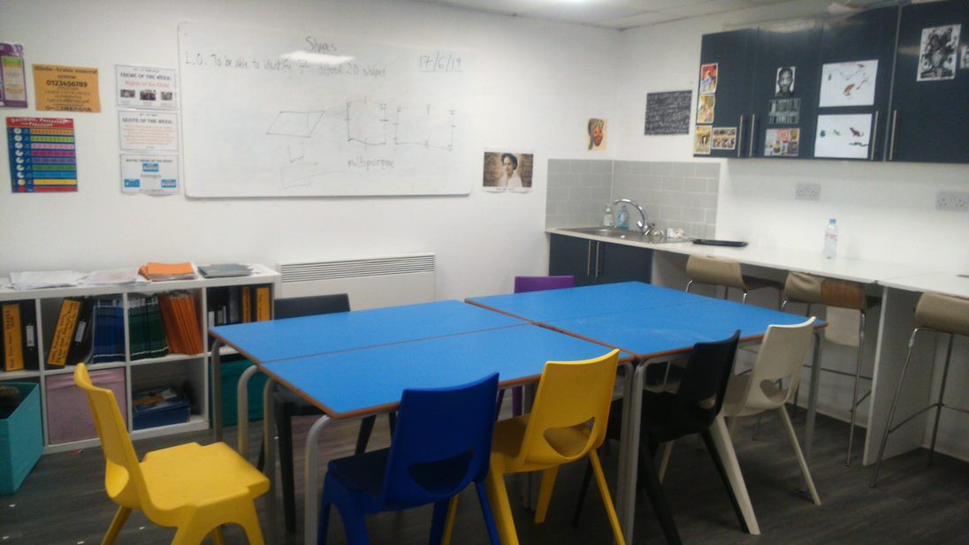
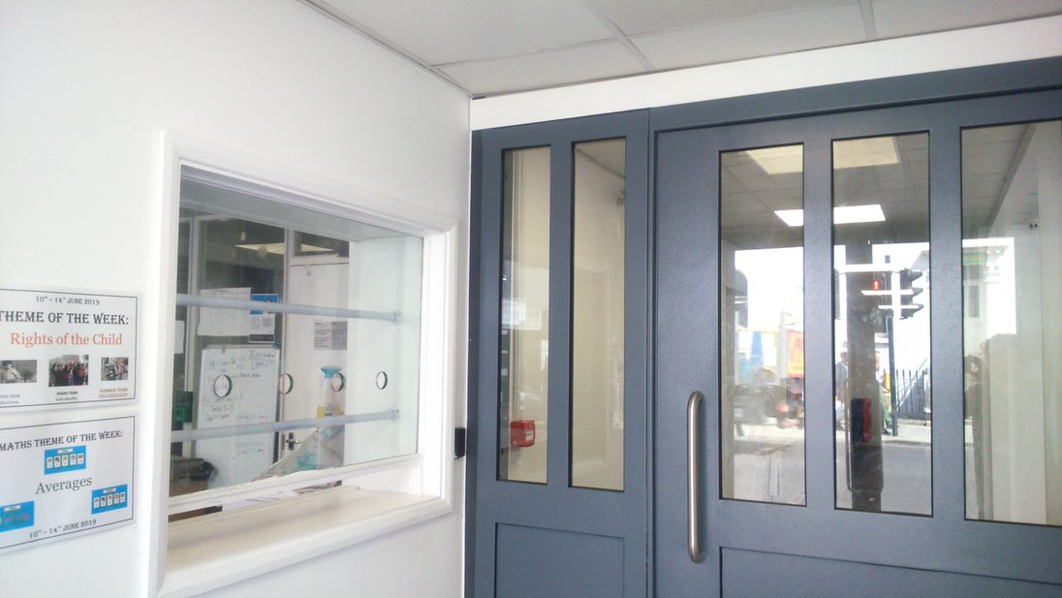
If you were to do the project again what would you do differently?
We ended up using the funding for slightly different changes to the premises due to changing needs throughout the year. We were grateful for the flexibility shown by West Hackney Parochial Charity, allowing us to meet the main needs of the our students and the changing circumstances.
Did your project complete on time?
If not why not?
N/a

What help/support/advice would you need to develop community work in your area? Is there any help/support/advice that you would like to have received during the project?
N/a
How useful was the grant? Would you have started the project if there had been no grant from West Hackney Parochial Charity?
Without the grant from the WHPC, we wouldn’t have been able to carry out the works and would not now be in a position to rent out our space and encourage community use.
How was the West Hackney Parochial Charity recognised as a donor?
We have recognized the WHPC as a donor on our website.
Other Comments

Declaration on behalf of the organisation to be completed by named official.

To the best of my knowledge, all the information that I have provided in this evaluation form is correct:

Signed: L Rafferty

Name: Lucy Rafferty Date: 30/09/2020

